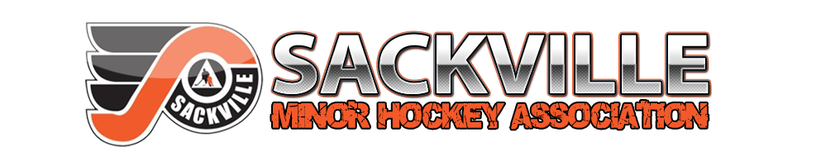

**Sackville Bruins – U13C Hockey Team**

October 2024

To a valued supporter of minor hockey:

The 2024/2025 season for the Sackville Bruins U13C Hockey Team has begun and we are competing in the Metro Minor Hockey League.

We are asking for your support to help with the costs of running our team through a team sponsorship banner. This will be displayed at our games, all team events and fundraisers.

Please select one of the following options for your business representation on our team banner

☐ $300.00 Bronze ☐ $400.00 Silver ☐ $500.00 Gold

SAMPLE:

Please make your cheque payable to “U13C Sackville Bruins” and a receipt will be provided.

**LOGO requirements please email to** [morganspicer@live.com](mailto:morganspicer@live.com)

*Vector Logos - Preferred (.eps, .ai, .pdf)*

*High Resolution Image File - Acceptable (.jpg, .png, .gif) (1000px x 1000px) is generally a good size or larger*.

Businesses in our community have been very supportive of our association in the past and we would sincerely appreciate any assistance you could offer for this hockey season.

The youth of our association thank you in advance for your consideration of this request.

Thank you so much