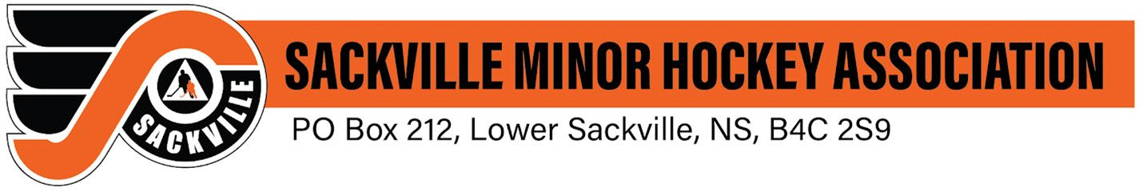Dear Community Supporter,

The 2025-2026 season is underway for the Sackville Flyers U11B Orange hockey team, and once again we are competing in the Central Minor Hockey League. With over 800 local youth registered, SMHA continues to provide a positive environment where players can develop their skills, build friendships, and learn the values of teamwork and perseverance.

As a non-profit organization, we rely on the dedication of our volunteers, coaches, and the generous support of local businesses like yours to keep the cost of hockey manageable for families. Sponsoring a player’s jersey not only helps reduce the financial burden on players but also strengthens the community connection that makes hockey in Lower Sackville so special.

For $200, your business can proudly sponsor a jersey. Your company’s name will proudly be displayed on your sponsored player’s jersey.

Thank you for considering this opportunity to support youth hockey and the future of our community. Your contribution will have a direct impact on our team’s experiences this season.

We look forward to partnering with you in making this season a memorable one for all involved.

Yours in hockey,

Angela Pennell

Team Manager

Sackville Flyers U11B Orange Sackville Minor Hockey Association