NW MINOR HOCKEY ASSOCIATION

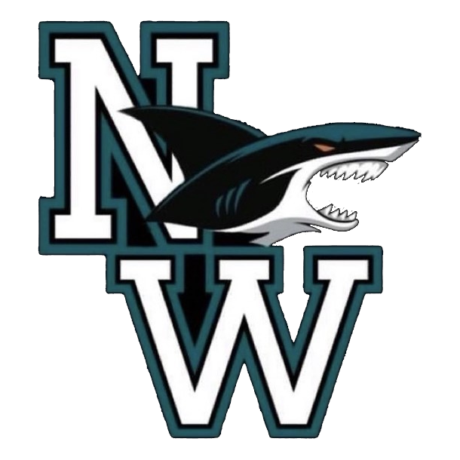

TEAM MANAGEMENT GUIDELINES
2025-2026

TABLE OF CONTENTS
- Team Manager role 3
- Communication/Gray jay 3
- NWMHA Policies 4
- Safety 4
- Medical information sheet
- Injury reports
- Bench staff
- Game day 5
- Game sheets sign off on Gray jay
- Affiliate players
- Referees/timekeepers
- Dressing room
- Game day music
- Weather
- Rescheduling league games
- Tournaments and exhibition games 6
- Travel permits
- Exhibition games
- Referees
- Fundraising 9
- Bank Accounts 11
- Miscellaneous 12
- Managers to-do list 12

Team Manager Role
The team manager is a volunteer leadership role on the team, the manager is the liaison between the parents, coaching staff, and NWMHA executive. You will work with the head coach, treasurer, and safety rep to ensure a safe and fun hockey season. The Role is rewarding and a fun way to be involved in your players NW Minor Hockey Team. Team Managers are required to have a valid Criminal Record Check with Vulnerable Sector, as well as the “Respect in Sport-Activity Leader” course. New for the 2025-2026 season. The Shift Forward course for volunteers is replacing the Respect in Sport Activity Leader. Every person listed on a team Bench Staff form is required by Hockey Canada, Hockey Nova Scotia and NWMHA to complete the Shift Forward by November 2026. For this season, the Respect in Sport - Activity Leader course is still valid until Nov 2026 and then will be replaced. It is recommended that at least some of the bench staff complete the Shift forward in the 2025 2026 season. Volunteers only need to take the Shift Forward course once; there is no expiry.
Communication /Gray Jay
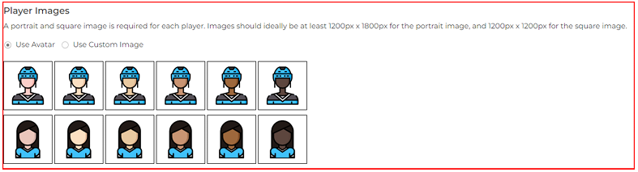
The manager will communicate all pertinent information to parents, including games, practice schedule, tournaments, and fundraising information. Managers will be linked to their teams through Gray jay. Once you receive access you can then update your rosters with jersey numbers, and more of the players information. You can even add photos of the players. When you are uploading the roster, if you edit player, you can change the gender and skin color of your player.

You will keep your team's calendar updated via GrayJay Leagues, once you update your team calendar on GrayJay Leagues it will sync to your team calendar on the NWMHA website. It’s important you include all team events on the NWMHA team calendar, as the executive looks at this when scheduling things or making changes to ice times. The Manager should coordinate a couple of team meetings throughout the year. This can be done informally during practice or after an ice time. It can include topics such as fundraising, budgets, schedule, tournament etc. Communication is always heaviest at the beginning of the season and it's important to advise the parents of this as it can be overwhelming, it’s the responsibility of the team manager to ensure that you have contacts for all the players and information is communicated in a timely fashion. The method of communication that will be used throughout the season can be discussed at the first parents meeting. Examples. Email, Team Management app such as Team Snap, team Facebook page, etc.
NWMHA Policy Review
Encourage parents to review the current policies and procedures on the NWMHA website.
• NWMHA Policies.
Safety
Obtain a complete set of player Medical Information Sheet one for each player. The player safety forms must always be with the team. The information on the form is to be kept confidential between the team manager and the head coach. It is mandatory, as indicated by Hockey Nova Scotia and NWMHA Minor Hockey, that a first aid kit is always accessible to the team, for on and off ice team activities.
Injury Reports
In the event a player or coach is injured on the ice the Hockey Canada Injury Report Form should be completed as well as the Hockey Injury Log. Email copies to the VP and Risk manager at dom_therrien@hotmail.com and mark.petrie@forces.gc.ca. A binder housing the medical information sheets, player contact information and blank injury forms are encouraged. This Binder should always be with the team. For players with serious injuries (that received medical attention), or concussions, all return to play protocols must be followed. The Hockey Canada Return to Play form must be signed by a physician prior to the player returning.

Bench Staff
Ensure an e-mail is sent to NWMHA Registrar, this should be completed ASAP once the team is formed, and coaches have been assigned. Once this has been sent to NWMHA your bench staff will be registered in the Hockey Canada Registry. Once the bench staff is registered in the Hockey Canada Registry you will be able to see what courses, safety checks each member is responsible for. Ensure these are completed in a timely fashion. All outstanding coaching courses must be scheduled by December 1st, or the coach will not be permitted to be on the bench until the course is completed. All bench staff need to have a valid back check in their HRC (Hockey Canada Registry) Profile. If this not completed by December 1st it will result in a suspension of the bench staff member.
Questions regarding back checks can be sent to the Risk Manager at mark.petrie@forces.gc.ca

Game Day
Competitive teams at NWMHA are part of the North Conference Minor Hockey League (NCMHL) and is the sanctioned league within Hockey Nova Scotia. The manager or coach is responsible to ensure the game sheet is uploaded via Gray Jay, confirming the team roster and bench staff for the game. Continue to check your Grayjay website throughout the season for potential changes to the schedule.
GAME SIGN OFF INSTRUCTIONS:
You need to “sign off” inside of GrayJay, before every game:
- Login to GrayJay League
- Select Games on left-hand drop-down menu
- Click Away or Home Sign Off
- Update your Roster and Bench staff with game participants
- Sign electronically and Submit
- Affiliate Players are a discussion between the coaches of both teams. If an AP will be playing a game or attending a practice with the team you manage, please ensure you have a copy of the players Hockey Canada Medical Information Sheet. For a game, if the player wears the same jersey number as a player on your team you can offer them your extra team jersey or modify their own jersey number with tape! Add this player to your team roster on Gray Jay for games and sure you click AP. Connect with the VP for confirmation on frequency of usage of an affiliated player.
- Timekeepers / Referee’s The association will organize Referee’s and Timekeepers for all regular league games.
- Dressing Room in partnership with the team coaches, the manager will help ensure that the parents and players are aware of the expectation of behavior and language in the dressing room. The two deep policy is to be followed.
- Dressing Room Music Effort should be made to ensure music played in the dressing room is non-offensive. Music that is racist, homophobic, sexist or culturally insensitive should NOT be played in dressing rooms.
- Weather If a game needs to be rescheduled due to weather or a conflict with a tournament etc. Notify the NWMHA Ice Scheduler immediately. Re-scheduling of games should be done between the Association's Ice Scheduler through the Team Managers. Typically, the traveling team will have the final say about a game being rescheduled due to the weather. There are no forfeits in minor hockey for weather. HNS-Winter Travel Policy
- Rescheduling league games If there is a game that you cannot play it is your responsibility to reach out to the opposing team to let them know. Please try to give as much notice as possible. It is your responsibility to reschedule that game at a later time. Once you find ice with our ice scheduler, he will then let the league scheduler know of this game/change and it will then be added to grayjay by the league scheduler. Please let the RIC and Timekeeper scheduler know of this game change as well to ensure you have officials for your game.

Tournaments and Exhibition Games
Tournaments are a large part of the hockey season, teams will usually play in 3-4 tournaments, it’s encouraged to decide on tournaments and registrar early in the season as most will fill up quickly. Accommodations should be organized along with the tournament, it can be difficult to get accommodations for some of the more popular tournaments, such as tournaments in PEI, SEDMHA or The Joe. Ensure you put a room block in for enough rooms to accommodate split families and nonparent coaches. Once you have organized the room block, families will book individual rooms. Once you have booked a tournament email the NWMHA Ice Schedular at dom_therrien@hotmail.com they will work on ice times for rescheduling any league games that conflict with the tournament. Tournaments can be found at:
1) Nova Scotia- Minor Hockey Tournaments | Hockey Nova Scotia , You can also visit association websites, if they are hosting any.
2) New Brunswick Hockey New Brunswick - Minor Hockey
3) PEI – EVENTS | HOCKEY PEI
- Travel Permits are required by all teams (competitive, recreational, and U9) playing a game outside of the North Conference, including exhibition and tournaments, requires a travel permit. You can apply for this on the Hockey Canada Registry.
Applying for a Travel Permit
1. Sign into your HCR account - www.register.hockeycanada.ca
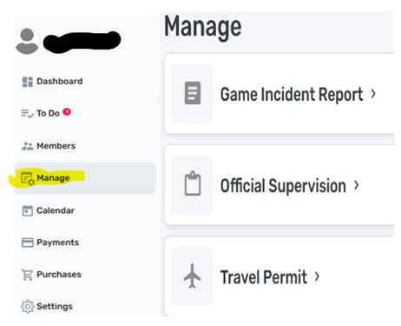
2. You will find a Menu to the left hand of the screen. You will find Travel permits under Manage.

3. Follow the prompts and click . Complete the requested information and submit.
4. Once approved, the document will be available for download by clicking on the permit requested and then actions. 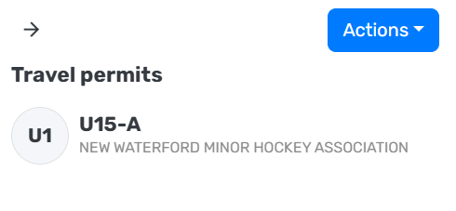
5. Approvals generally happen within a week. You will also receive an email a few days before your event letting you know the travel permit is ready for printing. 8 A team playing a tournament or exhibition game without a proper travel permit will NOT be covered by insurance. Be prepared to provide your travel permit to the hosting teams.
Hockey Nova Scotia Regulation 9.3 Any team playing out of the province must send a copy of the game sheets to the Regional Director within five days upon the return of the team. There must be 1 game sheet for each game played (unless the game was logged in Gray Jay).

- Exhibition Games
A few exhibition games can be played throughout the regular season, it’s up to the manager to organize the game, ice, and team in coordination with the head coach. You can email the away team’s manager to set these up. The number of games noted below include league games, exhibition games, and tournament games. A tournament counts as three games, regardless of the number of games played. Regional Conference, Day of Champions and Provincial and league playoff games are not included.

- Be aware of how many regular season games your division and level are allowed to play. Tournaments are equivalent to three games.

- U9 – A max of 24 half-ice games (including jamborees) not starting before Dec.1st. U9 is allowed between 4-12 full-ice controlled games starting February 1st – you must apply for travel permits.
- U11- 45 games
- U13- 60 games
- U15- 65 games
- U18- 65 games

Booking Referees,
you must email our RIC Scott at soccermabee21@gmail.com to confirm the booking of the referees for your exhibition game, he will also add the game into Grayjay. You will need to pay the refs cash from team funds for the exhibition game. Timekeeper for the games can be arranged by emailing the NWMHA timekeeper scheduler lucascamp6789@gmail.com , they will also require cash payment from the team funds. (You can confirm the cost for Ref’s with Scott; this will change depending on the length of the game and the division).
Fundraising
All fundraising is to be approved by NWMHA. You must send an email to our secretary ash.hillier@hotmail.com with your fundraising request and it will be signed off on by our president. Please include your division, which fundraiser you want to do and the dates you want to fundraise. We will supply a letter of approval allowing you to apply for the correct licence for your fundraiser.
There are very strict guidelines set out by the Alcohol and Gaming NS for selling of tickets and conducting draws. Please read all below information to make sure you understand it.
I have compiled some of the most frequently asked questions and answers below.
1. What method of payments can we receive/send?
a. NO online payments (i.e.. e transfer) can be accepted or be used to pay out winners. The only accepted method of payment to NWMHA is cash or cheque in person, which is to go directly to the NWMHA team bank account and not a personal account of a team member/staff. If a team manager or parent accepts an e transfer, NWMHA will lose the ability to apply for permits/licenses for the entire organization. The person accepting/advertising e-transfer is also subjecting their personal accounts to a government bank freeze and audit. This happened in the Sackville Flyers organization a few years ago, so it is imperative that no e-transfers are accepted or used to pay out winners.
2. Social Media - Can we advertise 50/50's, raffles, gift card draws, etc. on social media such as Facebook/Snapchat/Instagram?
a. We CAN advertise our draws/fundraisers online, but we cannot advertise or accept online payments such as e transfer.
3. Unpermitted Types of Draws/Fundraisers:
a. Selling 'Squares' is not permitted by AGD. You MUST sell a physical ticket and collect the purchaser's information. You may also not sell rolls of tickets (ie. 50/50 stubs). All tickets (except for RaffleBox digital tickets) must be a printed ticket with a ticket number, lotto #, purchasers name and contact info, etc. Items such as square boards, paper ticket 50/50's, etc will ONLY be approved for single day/event draws such as live hockey game 50/50's.
b. NSLC gift cards are acceptable for prizes however, alcohol/drugs are not.
4. AGD Licenses / Permits:
a. All teams conducting ‘games of chance’ (e.g. 50-50, raffle draws, sports lottery, etc.) as part of their fundraising WILL require a lottery license (Over $4k) or permit (Under $4k). These are provincially regulated and issued by the NS Alcohol and Gaming Division (AGD).
b. Please note the requirements for Lotto licenses and permits are different depending on prize value and type of fundraiser. If the value of prizes awarded (prize value-not ticket sales) is under $4000, you must obtain a lotto permit which can be obtained online in minutes.
c. If your prize value exceeds $4000 or is a building jackpot (such as Chase the Ace, Loonie, Toonie or Snowball or a Sports Lottery) you are required to obtain a lotto license, which may have associated fees and lotto report requirements. The team manager will be required to obtain said licence/permit and will be required to ensure that the lotto report is filed and fees are paid.
Please note a separate license or permit is required for every event that includes a game of chance.
d. The process for Lottery permit (under $4000) for NWMHA includes the following steps:
i. Applications for Lottery Licenses are to be submitted to the AGD by the Team Manager
ii. Access the following form and complete all the information. Lottery Application
iii. Send the completed form to our secretary, ash.hillier@hotmail.com it will be reviewed and passed off to the president to be signed. Once this is completed the form will be sent back to you along with an approval letter.
iv. Completed form (with president signature) AND approval letter must then be sent to AGD at AGDLicense@novascotia.ca
It may take up to 2 weeks

Bank Accounts
The Team Manager can make an appointment at RBC to setup a bank account; however, personal accounts cannot be used. Each account must be issued in the name of the team and there must be two signatures on every cheque( Team manager(s) and/or head coach). Please contact the secretary (ash.hillier@hotmail.com) to obtain a letter authorizing the opening of the account to take to the bank.

Miscellaneous items
- Ordering name bars/ sponsor bars for jerseys.
- Providing contacts for parents to have name bars, sponsor bars put on jerseys.
- Distributing corporate sponsor letters to families. (This letter will vary depending on the division and level of hockey).
- Team events (ex, end year party, team meals).
- Organizing team pictures
- Distributing team jerseys and collecting them back. Ensure the Jersey Tracker is completed and signed by the parents. Ensure they are aware of the Jersey policy. Jerseys must be returned to NWMHA at the end of the season. U7, U9 teams and U11 recreation teams - Jerseys are yours to keep.

Manager’s To Do List
- Once the team has been formed, send out an introduction email to advise of the team leadership, initial practice times and set up a Team Meeting
- Set up a scheduling app if you want(TeamSnap, Team Linkt, Gray Jay) and send out invites to the team. Encourage everyone to keep their availability up to date.
- Host a team meeting (in person or via teams) to set the expectations for the kids and the parents. Provide to the parents, all forms (medical, sponsorship, fundraising, tournaments, etc.)
- Book your tournaments - These fill up fast and accommodations should be booked at the same time.
- Book extra ice (parent paid) - If needed
- Ensure the team’s scheduling App is kept up to date with all practices and games (these could change, so keep checking) you can add all your practice times into Gray jay for parents who can then “Subscribe” to the team’s schedule. Remind parents of the importance to keep availability current and to advise in advance as much as possible if a player is not available.
- Organize team wear (game dress code) - If needed
- Book team photos - If needed
- Book team events including year-end celebration.

