Go to website: https://page.spordle.com/east-hants-minor-hockey-association
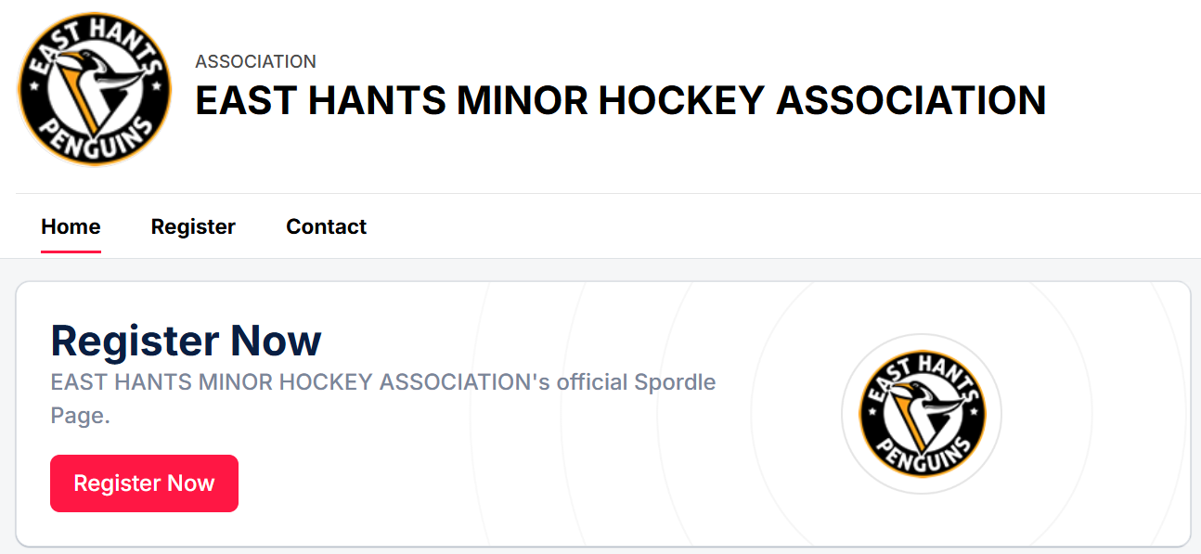
Click Register Now
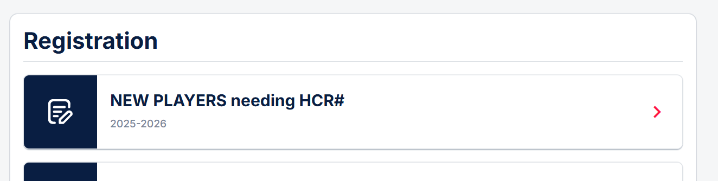
Click NEW PLAYERS needing HCR#
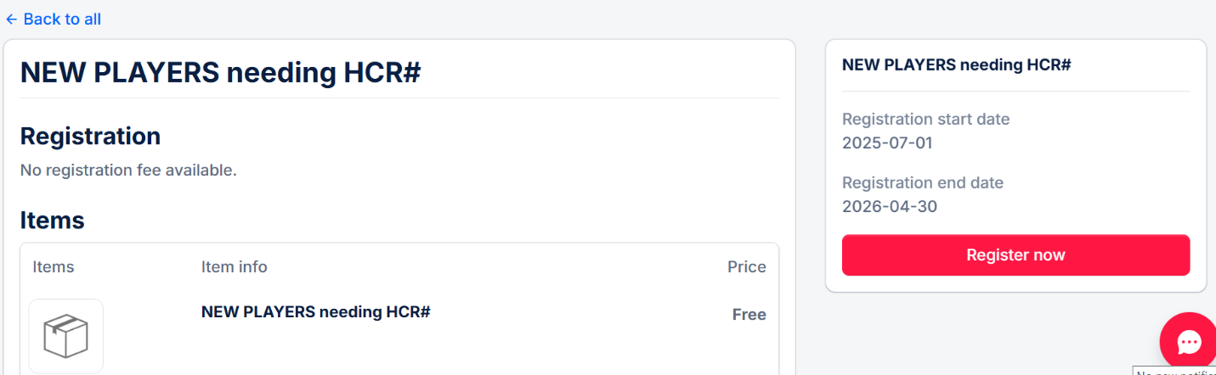
Click Register now
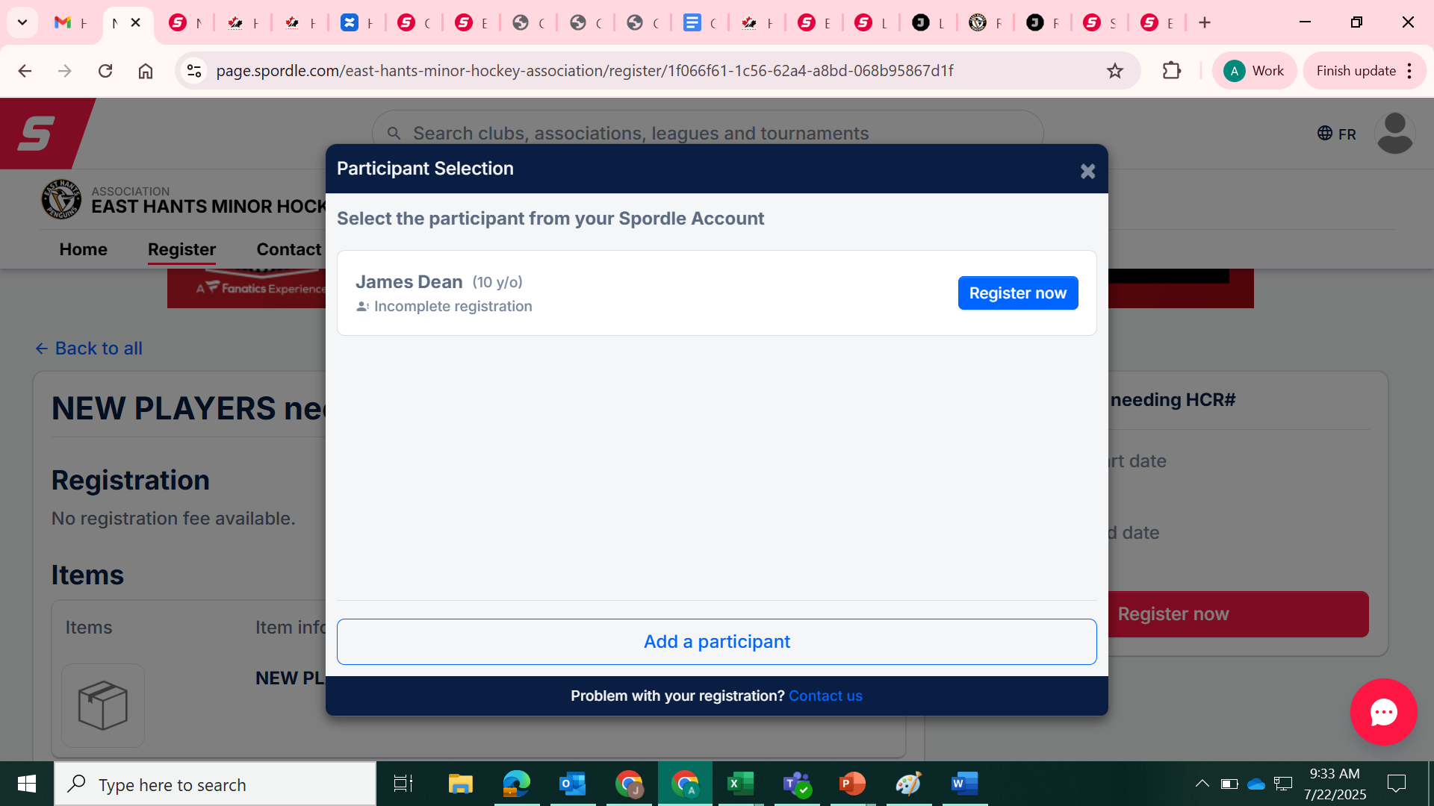
Click Add participant (on the bottom). Ignore the James Dean on the screen shot. 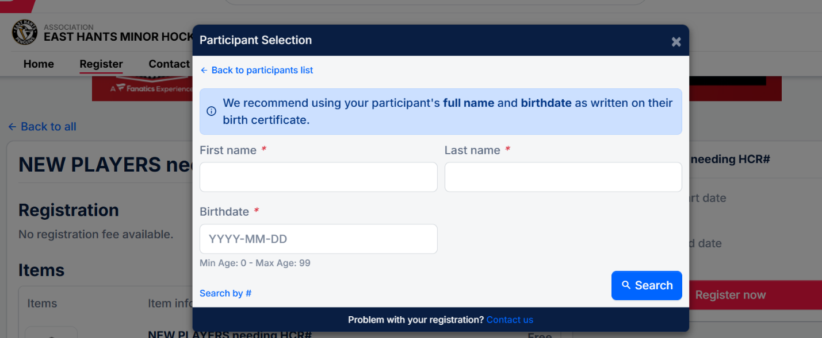Enter CHILD details and click search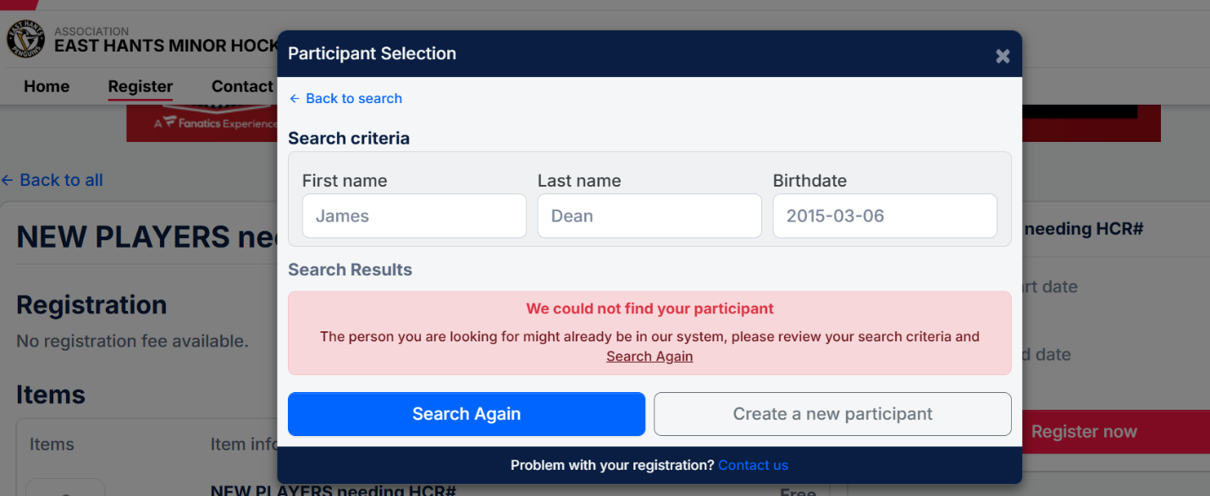
Click create a new particpant
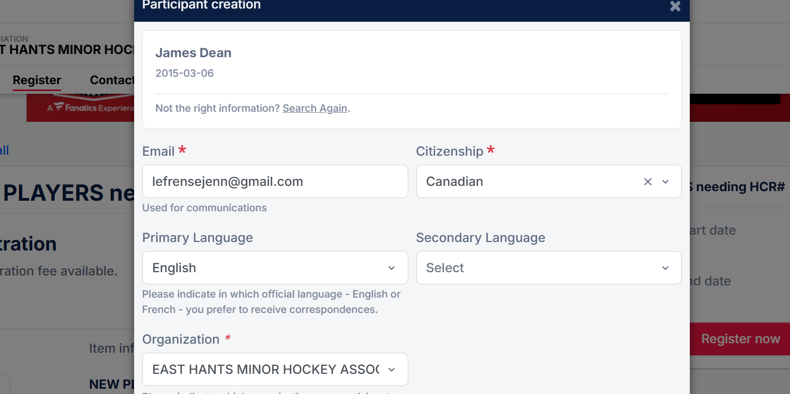
Fill in all mandatory fields and click create on the bottom of the screen.

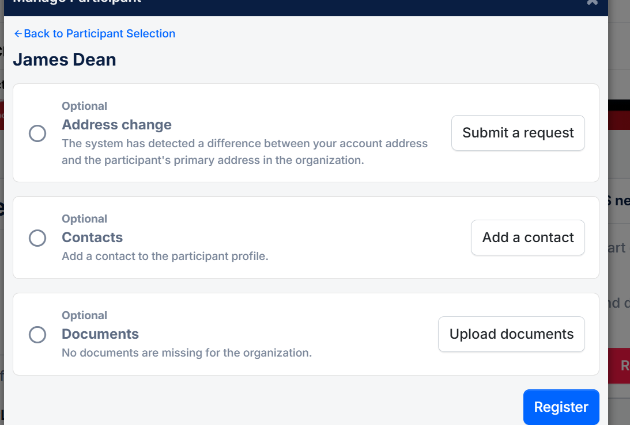
Click Register
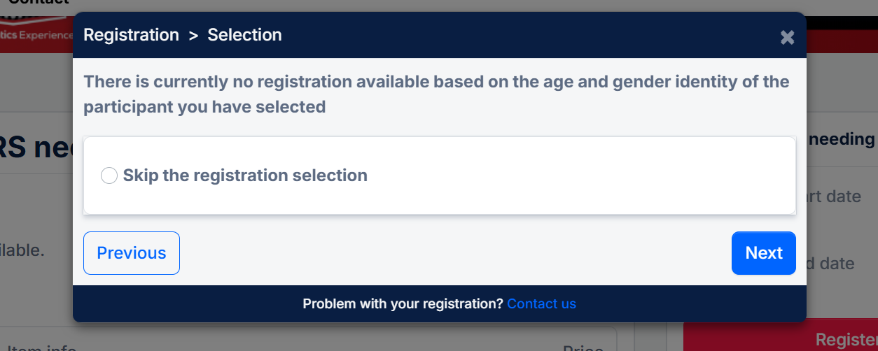
Select skip the registration process and click next
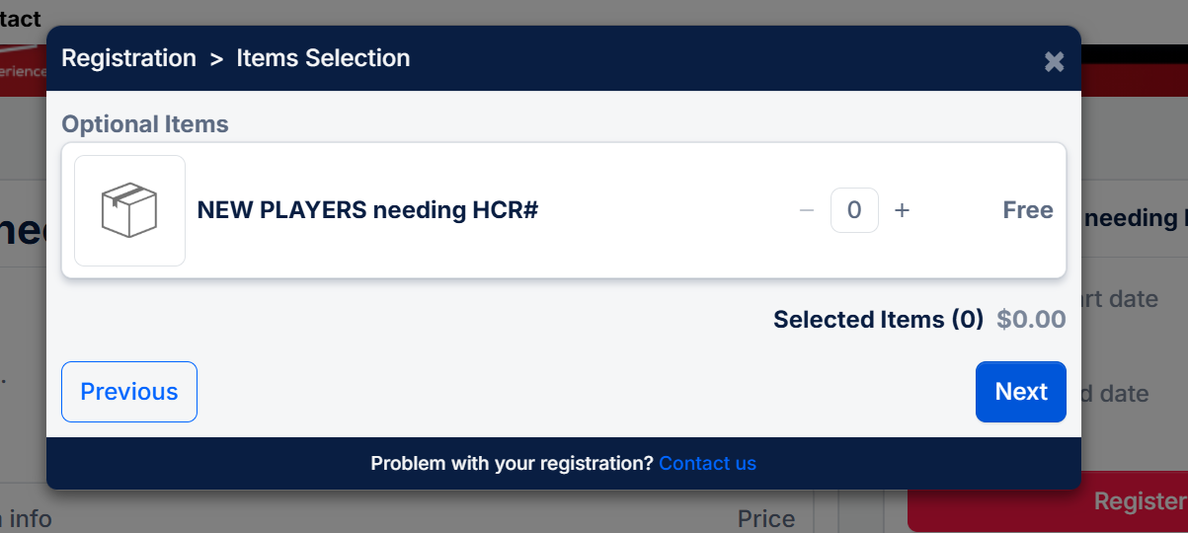
Enter 1 for a quantity and select next
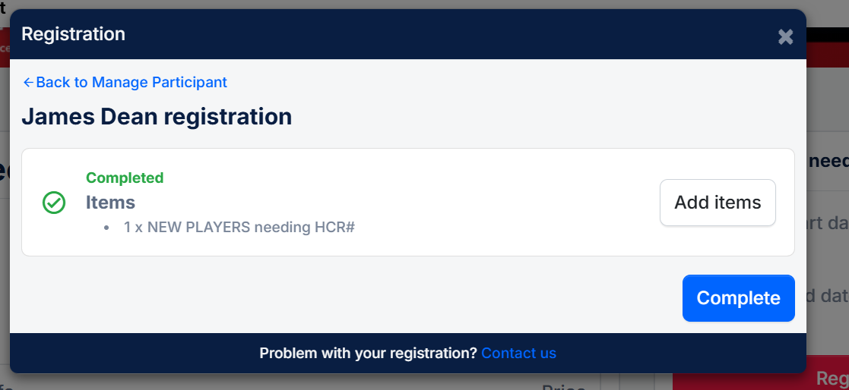
Click complete
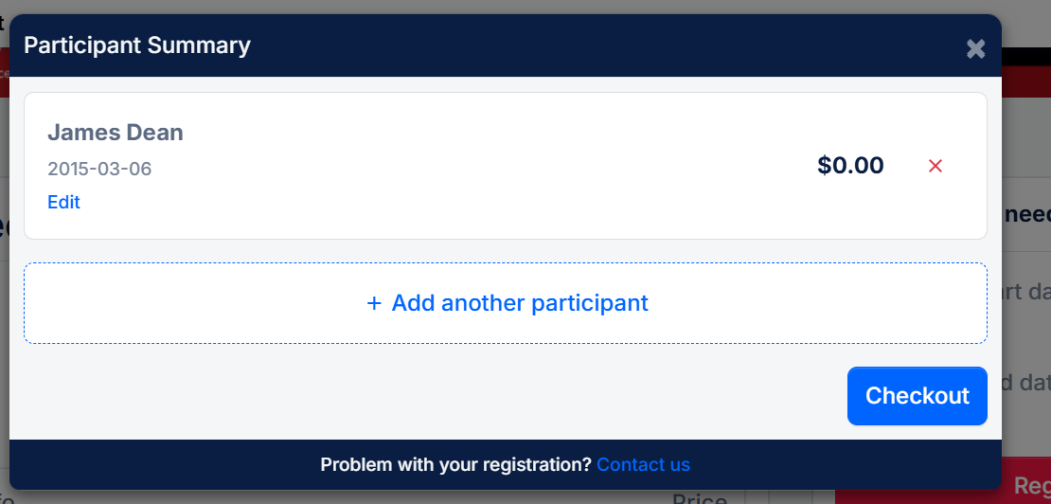
Click checkout
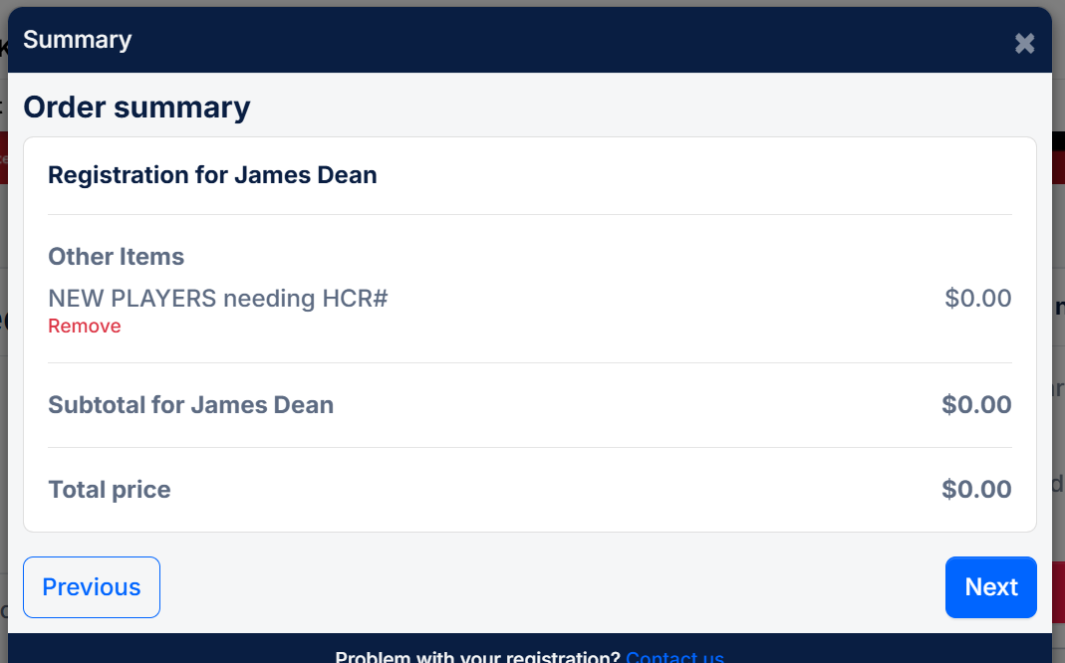
Click Next
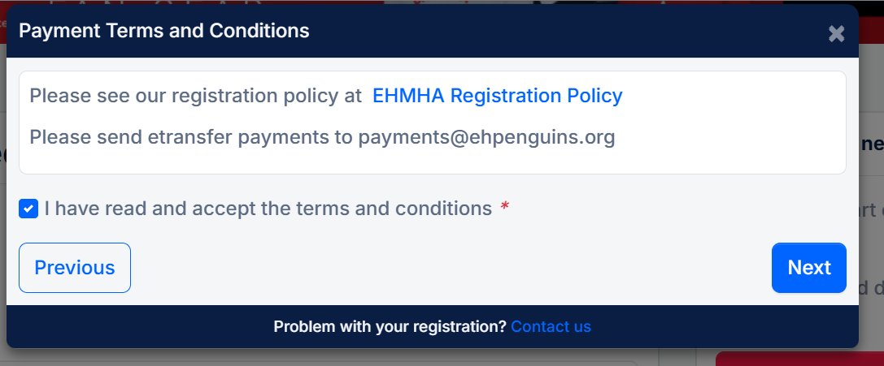
Select you have read and accept the terms and conditions and click next
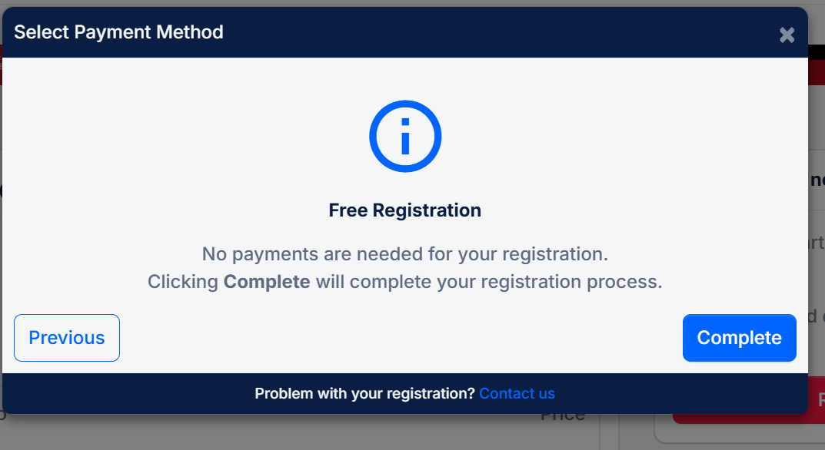
Click complete
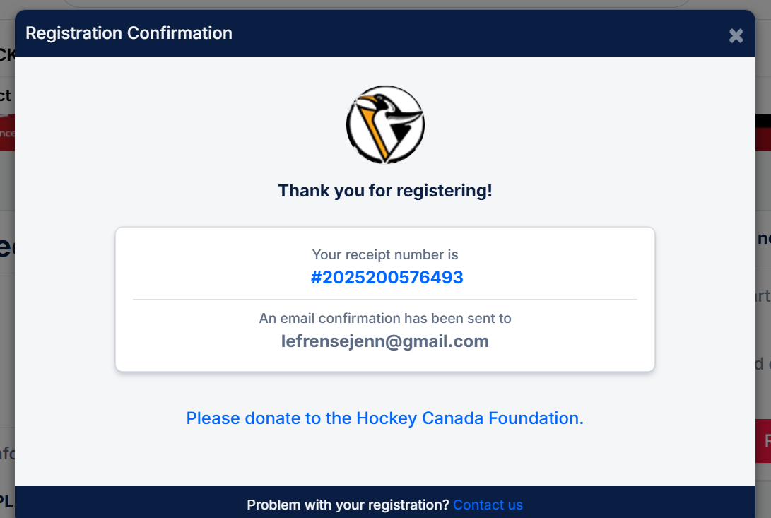
Close this box and return to the main page.
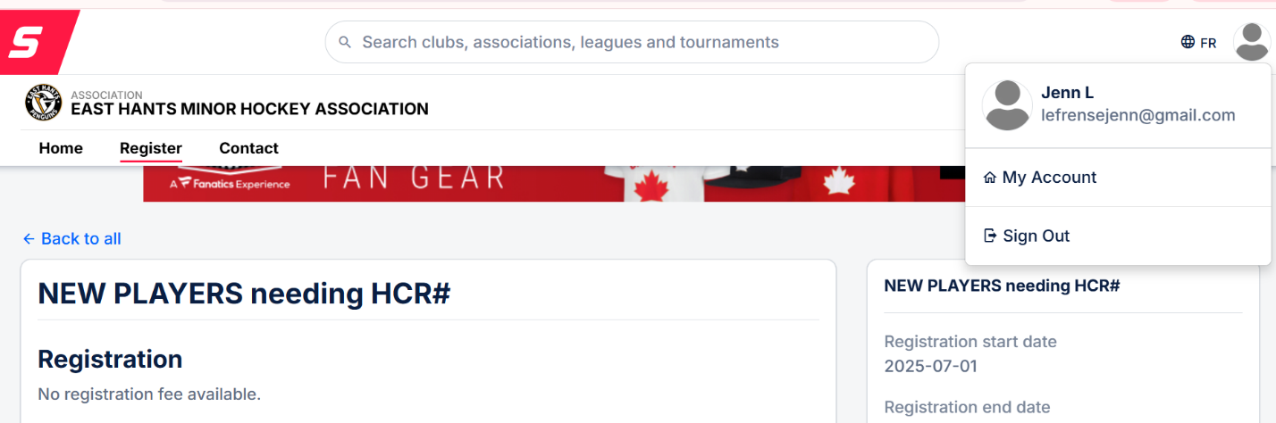
Select My account from the dropdown of the little man icon in the top right corner.
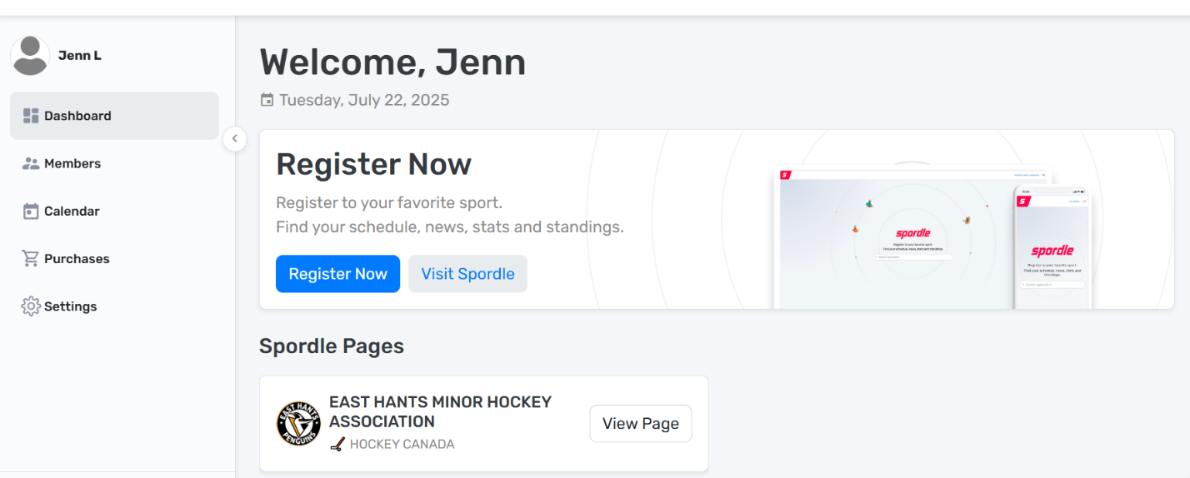
Click members on the left hand tool bar
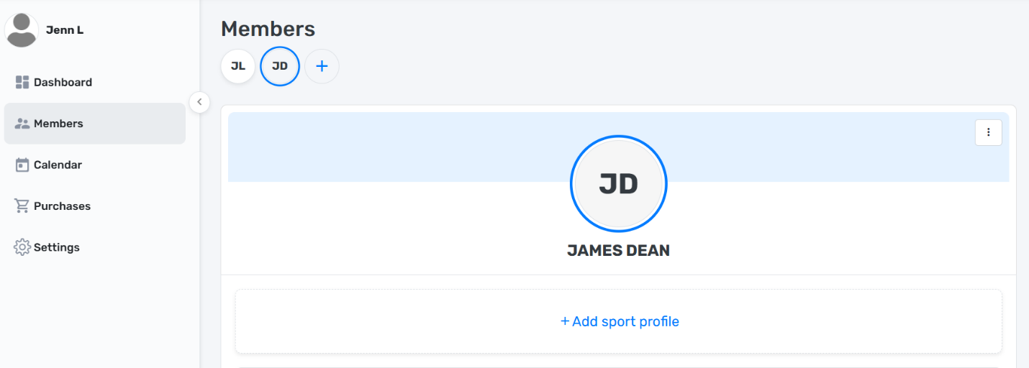
Select your childs initials in the circles under members
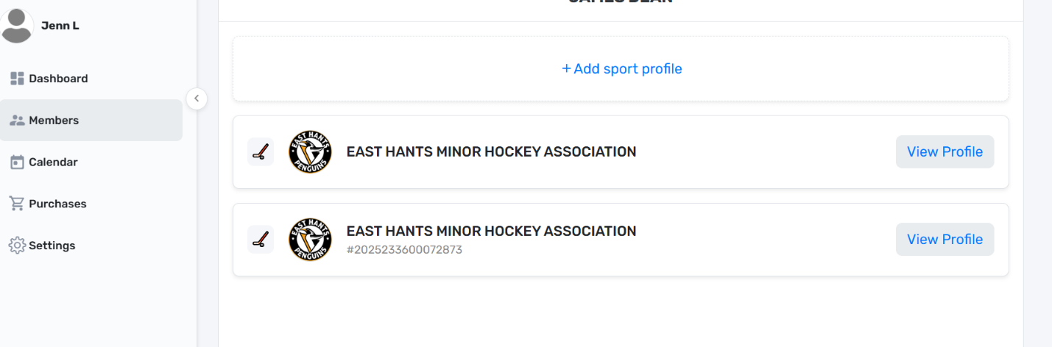
Select view profile on the second EHMHA or the one that shows a number underneath it.
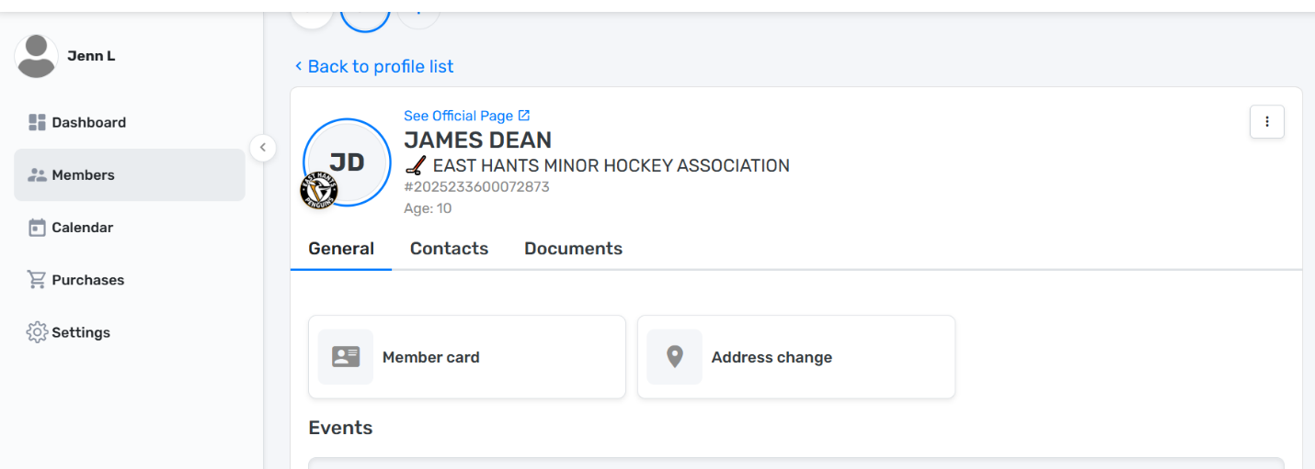
Hover over the number below the associations name and two file folders will appear for you to copy the number
