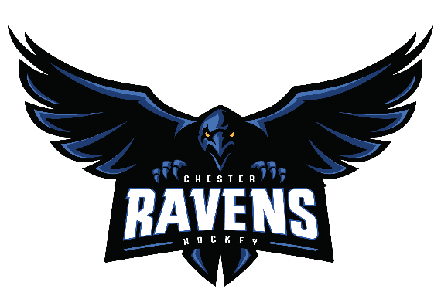
Dear Coaching Applicant,
Thank you for your interest in coaching with Chester Minor Hockey Association. Coaches help our players learn, grow, and enjoy the game of hockey.
To apply, please complete both forms in this package: the CMHA coaching application and the Hockey Canada’s Fair Play Code For Coaches. The CMHA coach selection committee and executive will review applications. Some applicants may also be asked to take part in an interview. Team levels will depend on registration numbers and player skill levels.
All bench staff, including coaches and managers, must complete a criminal record check and vulnerable sector check. These are required by Hockey Nova Scotia and Hockey Canada. Coaches must also complete the required training listed on the Hockey Nova Scotia website: https://hockeynovascotia.ca/coach/coaching-requirements. These items must be submitted by December 1. Checks are valid for three years. CMHA will try to send reminders, but each coach is responsible for meeting these requirements.
Please email your completed forms to president@chesterravens.com by August 31, 2026.
All the best,

President, CHMA

CMHA Coaching Application Package 2026–2027
Name
Address
Home Phone
Cell Phone
Email
Hockey Canada Registry (HCR) #

Application Details
Division applying for — check all that apply
☐ U-7 | ☐ U-9 | ☐ U-11 | ☐ U-13 | ☐ U-15

Role applying for — check one or both, as applicable
☐ Head Coach | ☐ Assistant Coach

First Aid and Safety Training
To help our Risk Manager plan for the association’s training needs please complete the following section.
I have completed the following certifications and they are currently valid for the upcoming season. Check all that apply:
☐ | Hockey University — Online Safety Program
☐ | CSA Basic First Aid / Emergency First Aid
☐ | CPR Level C
☐ | AED
Certifications which expire within the current year will be honored by Hockey NS until the end of the current season.

Recent Coaching Experience
Coaching experience is not required to volunteer. If applicable, please provide your coaching experience below.
Season | Organization/Level | Role

Personal Statement
Please tell us about your coaching approach. In your response, you may wish to describe how you would support player development, create a positive team environment, communicate with players and families, manage fair play and parental and player expectations, and model good sportsmanship.
Applicant response

Applicant Declaration and Signature
I confirm that the information provided in this application is accurate to the best of my knowledge. I understand that coaching appointments are subject to CMHA review and approval, completion of required screening, and confirmation of all applicable Hockey Nova Scotia and Hockey Canada coaching requirements.
Applicant Signature | Date

Hockey Canada - Fair Play Code for Coaches
1. I will be reasonable when scheduling games and practices remembering that young athletes have other interests and obligations.
2. I will teach my athletes to play fairly and to respect the rules, officials, opponents and teammates.
3. I will ensure all athletes receive equal instruction, discipline, support and appropriate, fair playing time.
4. I will not ridicule or yell at athletes for making mistakes or for performing poorly. I will remember that children play to have fun and must be encouraged to have confidence in themselves.
5. I will make sure that equipment and facilities are safe and match the athlete’s ages and ability.
6. I will remember that children need a coach they can respect. I will be generous with praise and set a good example.
7. I will obtain proper training and continue to upgrade my coaching skills. I agree to abide by the principles of the FAIR PLAY CODE as set by Hockey Canada and supported by Chester Minor Hockey Association. I also agree to abide by the rules, regulations and decisions as set by the CMHA.

Coach Acknowledgement
Name | Date
Signature

