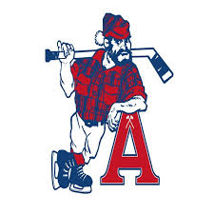

**ACADIA AXEMEN / AMHA Conditioning Camp for Try Outs**

**UPDATE: NEW GROUP ADDED FOR U15/U18**

The Acadia Minor Hockey Association in conjunction with the Acadia Axemen will be running a conditioning camp leading up to the 2024 try outs. The camp will consist of 7 one-hour ice sessions that will be instructed by the Acadia Axemen coaches & players. The ice sessions will focus on skating, puck skills, station work, flow drills & small area games.

**U15/U18 Group 2**

Sat Sept 7: 4-4:50pm

Sun Sept 8th: 4-4:50pm

Tues Sept 10th: 6:30-7:20pm

Thurs Sept 12th: 6:30-7:20pm

Sat Sept 14th: 4-4:50pm

Sun Sept 15th: 4-4:50pm

Tues Sept 24rd: 6:30-7:20pm

**U15/U18 Group 1**

Sat Sept 7: 2-2:50pm

Sun Sept 8th: 2-2:50pm

Mon Sept 9th: 8-8:50pm

Wed Sept 11th: 8-8:50pm

Sat Sept 14th: 3-3:50pm

Sun Sept 15th: 2-2:50pm

Mon Sept 23rd: 8-8:50pm

**IF YOUR CHILD IS ALREADY REGISTERED IN GROUP 1 YOU WILL NOT BE ABLE TO MOVE THEM TO GROUP 2! THERE WILL BE NO EXCEPTIONS AT THIS TIME. - As per the Competitive Chair**

**FULL**

TO REGISTER LOGIN TO YOUR GRAYJAY ACCOUNT

ANY QUESTIONS PLEASE EMAIL

ACADIAMINORREGISTRAR@GMAIL.COM