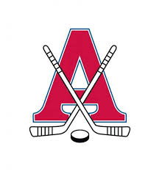 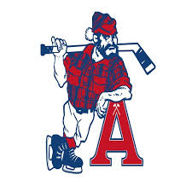

**ACADIA AXEMEN / AMHA Conditioning Camp for Try Outs**

The Acadia Minor Hockey Association in conjunction with the Acadia Axemen will be running a conditioning camp leading up to the 2025 try outs. The camp will consist of 7 one-hour ice sessions that will be instructed by the Acadia Axemen coaches & players. The ice sessions will focus on skating, puck skills, station work, flow drills & small area games.

|  |  |
| --- | --- |
| **U9**  Sat Sept 6th: 11-11:50am  Sun Sept 7th: 11-11:50am  Mon Sept 8th: 6-6:50pm  Wed Sept 10th: 6-6:50pm  Sun Sept 14th: 11-11:50am  Tues Sept 16th: 6-6:50pm  Thurs Sept 18th: 6-6:50pm | **U11**  Sat Sept 6th: 12-12:50pm  Sun Sept 7th: 12-12:50pm  Tues Sept 9th: 6-6:50pm  Thurs Sept 11th: 6-6:50pm  Fri Sept 12th: 5:30-6:20pm  Sun Sept 14th: 12-12:50pm  Mon Sept 15th: 6-6:50pm |
| **U13**  Sat Sept 6th: 1-1:50pm  Sun Sept 7th: 1-1:50pm  Mon Sept 8th: 7-7:50pm  Wed Sept 10th: 7-7:50pm  Sun Sept 14th: 1-1:50pm  Tues Sept 16th: 7-7:50pm  Thurs Sept 18th: 7-7:50pm | **U15/U18**  Sat Sept 6th: 2-2:50pm  Sun Sept 7th: 2-2:50pm  Mon Sept 8th: 8-8:50pm  Wed Sept 10th: 8-8:50pm  Sun Sept 14th: 2-2:50pm  Tues Sept 16th: 8-8:50pm  Thurs Sept 18th: 8-8:50pm |

**\*\*COST: $192 (GOALIES ARE HALF PRICE)**

**\*\*MAXIMUM 30 SKATERS PER CAMP.**

**IF YOU HAVE ANY QUESTIONS, PLEASE E-MAIL:**